TABLE OF CONTENTS
(Click on policy name to advance to policy. Click on policy name again to return to Table of Contents.)

Policy Name: Policy #:
Formation 5092
Structure 5094
Chair & Vice Chair 5096
Function 5098
Procedures for Appointment of TDAC Members 5100
Procedures for Appointment of TDAC Members – Letter 5101
Procedures for Appointment of TDAC Members – CC Participation 5102
TDAC Member Evaluation Criteria and Process 5103
Meetings 5104
Off-Site TDAC Meeting Venue Selection 5105
Travel Reimbursement Policy 5106
Travel Agency 5107
Travel Insurance Beneficiary Form 5107.1
Operating Procedures 5108
Confidentiality and Conflict of Interest Agreement 5111
Staff Assistance 5112
Guidelines for Question Writing 5114
Examination Coding System 5118
Processing of Microscopic Slides & Images 5120
Continuing Certification (Formerly MOC) – Introduction 5122
Standard Setting 5124
Continuing Medication Education 5200
Resources for Good Question Writing 5201
MANUAL RECORD OF CHANGES
Date | Change | Policy #
10/01/2019 | Published original version | All
10/23/2020 | Changed max reimbursement deadline to 30 days | 5106
07/15/2021 | Confidentiality and Conflict of Interest Agreement | 5111
06/14/2022 | Update to Off-Site TDAC Meeting Venue Selection policy | 5105
06/14/2022 | Update to Travel Reimbursement policy | 5106
02/01/2023 | Standard Setting policy | 5124
05/06/2024 | TDAC Member Evaluation Criteria and Process policy | 5103

5092 – TDAC Formation
Effective Date: 05/07/1997
Revision Date: 06/15/2021
- Decision to form a TDAC is based on an identified need and approval by the Board.
- President assigns responsibility of organizing a new TDAC to appropriate Trustee.
- Trustee with this responsibility develops a list of potential members and consults with other Trustees and CEO as needed.
- Other Trustees may recommend additional or alternate TDAC members.
- Pathology societies may be asked to recommend TDAC members.
- TDAC Chairs(s) make the appointments.
- Chief Executive Officer calls nominees explaining responsibilities and functions of the TDAC regarding objectives, confidentiality of material, reimbursement for expenses, types of questions to be created, letter of agreement, advisory function, and any other information deemed pertinent. Current contact information is obtained during this time.
- New member packet, including Confidentiality and Conflict of Interest Agreement, is sent to the new TDAC member by TDAC Coordinator.

5094 – TDAC Structure
Effective Date: 05/01/1997
Revision Date: 06/15/2021
- At present, there are 15 TDACs:
  - Anatomic Pathology (AP)
  - Blood Banking/Transfusion Medicine (BB)
  - Chemical Pathology (CH)
  - Clinical Informatics (CI)
  - Cytopathology (CY)
  - Dermatopathology (DP)
  - Forensic Pathology (FP)
  - Hematopathology (HP)
  - Management and Informatics (MI)
  - Medical Microbiology (MB)
  - Molecular Genetic Pathology (MG)
  - Neuropathology (NP)
  - Pediatric Pathology (PP)
  - AP ABPath CertLink (ABP AP CL)
  - CP ABPath CertLink (ABP CP CL)
The TDAC for Dermatopathology is a joint and equal function of The American Board of Pathology and The American Board of Dermatology.
The TDAC for Molecular Genetic Pathology is a joint function of The American Board of Pathology and The American Board of Medical Genetics and Genomics.
The TDAC for Management and Informatics is a joint function with The American Board of Pathology and The American Board of Preventive Medicine.
- TDACs shall consist of at least one ABPath Trustee and non-Trustees. The number of non-Trustees is determined by the Chair.
- There shall be a Chair and, where appropriate, a Vice-Chair appointed by the President. The Chair shall be a Trustee of the Board (except for DP which alternates the Chair position between the two Boards every two years).
- Non-Trustee members must be ABPath diplomates and should be recognized subject matter experts in the appropriate field with no conflicting interests with any other certifying body. Current TDAC members select a ‘short list’ of suggested nominees.
- All appointments of non-Trustees are on a yearly basis and are made prior to the year of service.
- Terms of non-Trustee members should be staggered to not have more than one member retire from the TDAC each year.
- Non-Trustee members must discharge all responsibilities to be eligible for reappointment.
- Maximum period of service is six (6) years unless otherwise approved by the TDAC Chair.
- Reappointment shall be at the discretion of the Chair of the Committee.
- The TDAC for Dermatopathology differs from the other TDACs of the ABPath in that its members are appointed with equal representation from The American Board of Pathology and The American Board of Dermatology. The TDAC consists of two members from the Joint Policy Committee for Dermatopathology and a maximum of eight nonmembers. The two members from the Joint Policy Committee for Dermatopathology will be Chair and Vice-Chair, one being from The American Board of Dermatology and the other from The American Board of Pathology. Procedures for appointments and reappointments are the same as for other TDACs.
- The TDAC for Molecular Genetic Pathology differs from the other TDACs of the ABPath in that its members are appoints by The American Board of Pathology and The American Board of Medical Genetics and Genomics (ABMGG). The TDAC consists of two members appointed by ABMGG and a maximum of eight members appointed by the ABPath. The Chair of the committee is a Trustee of the ABPath. Procedures for appointments and reappointments are the same as for the other TDACs.
- The Test Committee for Clinical Informatics (CI) differs from other TDACs of the ABPath. This Committee is composed of members from many subspecialties and meets at The American Board of Preventive Medicine (ABPM) office in Chicago. The ABPath appoints three members and reimburses their expenses. All functions, activities, work product, and responsibilities of this Committee are the purview of the ABPM. The ABPath does not have access to the CI item bank and has no responsibility for examination construction, administration, and standard setting. The ABPath assess the qualifications of our diplomates who want to become certified in CI, reports our diplomates’ CI examination results, and issues certificates to our successful diplomates. All other CI examination and certification functions are the responsibility of the ABPM. The ABPath and the ABPM have agreed upon requirements for those candidates seeking certification by experience (grandfather) through 2022.

5096 – TDAC Chair & Vice Chair
Effective Date: 01/01/1984
Revision Date: 06/15/2021
THE CHAIR OF THE TDAC SHALL:
- Be appointed by the President of the ABPath.
- Be a Trustee of the ABPath (exception for TDAC for Dermatopathology, see Policy #5094, section 10).
- Chair all meetings of the TDAC.
- In conjunction with the CEO and staff, shall schedule all TDAC meetings, review item bank needs, and determine assignments for TDAC members.
- Shall be responsible for overseeing creation of specialty examinations and relevant portions of primary examinations.
- Consult with the Vice Chair of the TDAC as needed.
- Have other duties and responsibilities as assigned by the President.
THE VICE CHAIR OF THE TDAC SHALL:
- Be appointed by the President of the ABPath (exception for TDAC for Dermatopathology, see Policy #5094, section 10).
- Assure appropriate liaison with the Chair of the TDAC.
- Assume duties and responsibilities of the Chair when necessary.
- Have other duties and responsibilities as assigned by the President.

5098 – TDAC Function
Effective Date: 05/01/1997
Revision Date: 06/15/2021
- The development of new questions for the written and practical examinations (including Continuing Certification) as requested by the Chair of the Committee. These may be questions for specifically designated categories, or the Chair may request the Committee members develop questions in categories of their own choosing and expertise.
- The preparation and assessment of digital images including graphs, charts, and illustrations with questions for the primary or subspecialty examinations.
- The preparation and assessment of virtual slides, and questions for use in the anatomic pathology and the subspeciality examinations in cytopathology, dermatopathology, forensic pathology, hematopathology, neuropathology, and pediatric pathology.
- Review of questions with poor statistical performance used on examinations (TCR – test committee review).
- Review of outdated questions by category code in the item bank, reworking or deleting them.
- The development and revision of category codes.
- Review and update the number/distribution of questions in each category on the examination (examination question grid/blueprint).
- Advise the ABPath of an issue that the TDAC members ask the Committee Chair to bring forward for discussion and recommendation for reporting to the Trustees.
- Other duties assigned by the Chair of the Committee and President of the Board.
- Review/update exam description for website.
- Identify/update manuscripts and guidelines.
- Review reference ranges as applicable for each TDAC.

5100 – Procedures for Appointment of TDAC Members
Effective Date: 07/01/1982
Revision Date: 10/08/2004
- TDAC membership is reviewed during each TDAC meeting. If a vacancy occurs in the following year, the TDAC will recommend, in ranked order, 3 nominees. Appointments are made throughout the year so that new members (member designates) will have time to arrange their schedules to attend meetings and to develop questions.
- In making the appointments, the Chair of the TDACs makes the final decision.
- The CEO contacts the nominee to explain TDAC responsibilities and assess the nominee’s willingness and ability to serve.
- The appointee is required to sign a letter of agreement (see Policy #5101).

5101 – Procedures for Appointment of TDAC Members – Letter
Effective Date: 07/01/1982
Revision Date: 09/12/2001
A sample letter is found in S:\ABP_TDAC\TDAC\LILY\THE BIBLE\2. Documents\TDAC Documents (originals)\New Member Send Out\TDAC NEW MEMBER AGREEMENT. A new letter is developed each year.

5102 – Procedures for Appointment of TDAC Members – CC Participation
Effective Date: 12/21/2017
Revision Date: 06/15/2021
All new TDAC members must participate in the Continuing Certification (CC) Program, including ABPath CertLink. Staff will enroll new members, if not already enrolled. All CC fees will be waived.

5103 – TDAC Member Evaluation Criteria and Process
Effective Date: 05/06/2024
Revision Date:
TDAC members may serve up to six (6) one-year terms. They will be evaluated annually after their first term per the below criteria, and based on the results, will be replaced if appropriate.
EVALUATION CRITERIA:
Collegial participation at meetings | Graded by Chair and CEO
Quality of item writing | Graded by Chair and CEO
Percentage of items completed per assignment – Did they do what we asked them to do? | TDAC Coordinator provide to CEO
Percentage of item submission deadline met – Did they do what we asked them to do on time? | TDAC Coordinator provide to CEO
Participation in ABPCL – Attempt all questions each quarter | CC Coordinator provide to CEO

EVALUATION PROCESS:
- Within two (2) weeks of the annual TDAC meeting, TDAC and CC Coordinator will provide their information to the CEO.
- Within one (1) month of the annual TDAC meeting, CEO and TDAC Chair will evaluate each TDAC member and determine if to offer another term to each.
- Ten (10) months before next annual TDAC meeting, one of two options may occur:
  - If it is the first instance of failing to meet the required standards and the individual is receptive to remediation, then another opportunity to participate will be given.
  - If it is the second instance of failing to meet the required standards or the individual is not receptive to remediation, then the TDAC Chair will notify the TDAC member that they will not be offered another term as a TDAC member and why.
- Nine (9) months before the next annual TDAC meeting, CEO and TDAC Chair appoint new TDAC member, if necessary.
- Eight (8) months before next annual TDAC meeting, CEO and TDAC Coordinator conduct new TDAC member orientation if necessary.

5104 – TDAC Meetings
Effective Date: 07/01/1982
Revision Date: 06/15/2021
- TDACs meet once a year, unless more or less frequent meetings are approved by the Chair and CEO.
- All meetings will be held in the ABPath office of at a place determined by the ABPath.
- Meetings should be scheduled so that the Board Staff can prepare any needed materials.

5105 – Off-Site TDAC Meeting Venue Selection
Effective Date: 05/06/2019
Revision Date: 08/07/2024
The following guidelines are provided to assist Trustees and ABPath Staff in the selection of off-site venues for TDAC meetings.
Off-site TDAC meetings will only be attended by the CEO and TDAC Coordinator from the ABPath Staff; exceptions must be approved by the CEO.
- The meetings must be held in the continental U.S. (lower 48 states).
- The venue must be within 120 miles of a commercial airport and not require extended boat/ferry service.
- Meeting costs should not exceed the following:
  - Hotel rooms - $550 per night.
  - Food and beverage costs should not exceed $290/day/person for off-site TDAC meetings. When a TDAC-sponsored group dinner occurs, the daily meal allowance for that day will be $140. When a TDAC-sponsored group breakfast or lunch occurs, the daily meal allowance for that day will be reduced by $65 or $75 for each group meal respectively.
Daily TDAC Member Meal Allowance (Away TDAC Meeting)
Total Daily Meal Allowance: | $290
TDAC Sponsored Group Dinner Occurs: | $140
TDAC Sponsored Group Dinner + Breakfast Occurs: | $75
TDAC Sponsored Group Dinner + Breakfast + Lunch Occurs: | $0
  - Group activity is allowed at off-site TDAC meetings and will not exceed $75 per individual.
  - Food and beverage costs should not exceed $125/day/person for TDAC meetings conducted in Tampa, FL. When a TDAC-sponsored group dinner occurs, the daily meal allowance for that day will be $50. When a TDAC-sponsored group breakfast or lunch occurs, the daily meal allowance for that day will be reduced by $25 for each group meal.
Daily TDAC Member Meal Allowance (Tampa TDAC Meeting)
Total Daily Meal Allowance: | $125
TDAC Sponsored Group Dinner Occurs: | $50
TDAC Sponsored Group Dinner + Breakfast Occurs: | $25
TDAC Sponsored Group Dinner + Breakfast + Lunch Occurs: | $0

  - Bottle of wine - $85
  - Glass of wine $15
  - Bottle of beer - $12
  - When possible, meeting rooms should be provided at no cost because of food sales.
- The venue must be able to accommodate the group with:
  - Secure meeting space with table and chairs for up to 18 participants that can be kept locked for the duration of the meeting; on a 24-hour hold.
  - Beverage station (coffee, tea, water & sodas) during the meetings.
  - Quiet space with solid walls (no accordion-type soft walls)
  - High-speed internet service
  - Electrical power outlets with surge protectors

5106 – Travel Reimbursement Policy
Effective Date: 01/01/1984
Revision Date: 06/14/2022
TRAVEL POLICY:
- Economy Coach class airfare will be reimbursed for TDAC members.
- Members may use ABPath’s travel agency for booking travel (see Policy #5107).
- Approval for rental car reimbursement must be obtained in advance.
- The ABPath will issue reimbursement 7-14 days after receipt of the Expense Voucher and receipts. Receipts for any expenses over $25 must be submitted.
- Expense Voucher should be submitted 10 business days after the meeting but no later than 30 days.
TYPES OF REIMBURSABLE EXPENSES:
- Personal Automobiles – Reimbursement for the use of a personal vehicle for ABPath travel is at the rate currently allowed by the IRS, plus any necessary parking or toll charges incurred. The per-mile rate covers all operating costs, including maintenance, gas, oil, depreciation, and insurance.
- Commercial Airline Travel – Members make their own arrangements for travel to the meeting site. Prepayment for tickets is the responsibility of the TDAC member. The ABPath will reimburse for economy-class airfare only. Ticket receipt must accompany the reimbursement request. The ABPath encourages economical practices such as purchasing tickets early and taking advantage of any available discounts.
- Hotel – Members must pay for their hotel stay upon departure. The ABPath will reimburse hotel nights starting one day before the meeting until the last day of the meeting. If you are unable to get home at a reasonable time after the meeting, the ABPath will pay for one extra night.
- Gratuities – Reasonable gratuities for baggage handling, taxis, housekeeping, meals, and other usual situations will be reimbursed.
- Ground Transportation (away meetings) – Reasonable expenses for automobile rentals, buses, taxis, ride-sharing company (e.g., Uber, Lyft), and parking fees will be reimbursed. Approval for rental car reimbursement must be obtained in advance.
  - Always decline the additional insurance coverage offered by the rental car company. Physical damage insurance is usually provided as a benefit of the credit card you use to pay for the rental but check with your credit card company before renting the vehicle.
  - Car rental should only be used when it is an economical alternative to other transportation arrangements. As the driver of a vehicle, your personal auto insurance provides protection for your personal liability in the event of an accident. If you do not have a personal auto policy, or other financial responsibility insurance, you must not rent or operate a motor vehicle while on ABPath business.
- Ground Transportation (Tampa) – A complimentary Westshore Grand Hotel shuttle service is available to a from the airport. However, a taxi or ride-share is also acceptable.
- Meals – For TDAC members, meals are reimbursed per Policy #5105 when food is not provided by the ABPath. This includes all meals, snacks, and in-room minibar. When more than one dinner is covered by a single receipt, names of all diners must be noted on the back of the receipt. Unless otherwise allocated on (or on a list accompanying) a meal receipt, the total number will be divided equally among all diners.
TYPES OF NON-REIMBURSABLE EXPENSES:
- All personal travel and lodging expenses incurred prior to or after a TDAC meeting are the responsibility of the member.
- Laundry and dry-cleaning expenses are not reimbursed unless there is a travel emergency.
- Accompanying guest of a TDAC member – Airfare, meals, and other expenses for accompanying guest are not reimbursed. The guest is welcome to attend group dinners and these meals will be paid for by the ABPath.
Any questions or requires for exceptions to this policy should be discussed with the ABPath office in advance of travel.
An Expense Voucher is available on the TDAC landing site and in Govenda.

5107 – Travel Agency
Effective Date:
Revision Date: 01/01/2019
The Board offers, on a voluntary basis, the use of its travel agency to those TDAC members who wish to have their airfares charged directly to the Board. To take advantage of this offer, please complete the online Travel Profile and submit it through the secure website of Bowen TravelWorld.
- Go to www.Travelworld1.com and hover the cursor over the box marked “CORPORATE”.
- Click on “Traveler Profile” and complete as much information as possible.
- You name must be EXACTLY as it appears on your driver’s license or passport, including middle names and/or initials, date of birth, and gender.
- Include information such as seating preference, frequent flyer numbers, phone contacts, and email.
- Click on “SUBMIT”. This information will be entered into a profile for your account.
When you wish to arrange air travel, call between 9:00 am and 5:00 pm (ET) and identify yourself as a TDAC member of The American Board of Pathology. Travelworld may be reached at 1-800-453-8344 or 813-289-8344. An after-hours emergency service number is 1-800-304-0642, give the agency the VIT code: E3075. If you prefer to use your travel agency or book your own travel, the fare will be promptly reimbursed when submitted on your expense voucher after the meeting.

5107.1 – Travel Insurance Beneficiary Form
Effective Date:
Revision Date: 01/01/2019
The American Board of Pathology has a travel accident policy to cover all members of the Test Development and Advisory Committees (TDACs) for travel related to TDAC activities. The coverage for all modes of transportation is:
$100,000 Death and Dismemberment, per member
$5,000 Medical Expense benefit, per member and term of coverage (5 days)
Name of Beneficiary: ___________________________________________________________________
Address of Beneficiary: ___________________________________________________________________
___________________________________________________________________
___________________________________________________________________
Comments: ____________________________________________________________________________
_______________________________________________________________________________________
_______________________________________________________________________________________

Name of TDAC Member: _____________________________________________________________
(Printed or Typed)
Signature of TDAC Member: _____________________________________________________________
Date Signed: _____________________________________________________________

5108 – TDAC Operating Procedures
Effective Date: 07/01/1982
Revision Date: 06/15/2021
- Chair of the TDAC, with Staff support, composes and sends a memorandum seven (7) months prior to a meeting, notifying Committee members of their assignment for examination questions and materials to be submitted and the deadline for submission. The memorandum includes information as to whether the exam material is to be for the primary examinations, subspecialty examinations, or Continuing Certification, for the written, practical, or VM examinations, and will indicate the type of questions required.
- Deadline for submission of examination materials is generally eight (8) weeks prior to the TDAC meeting.
- Questions and associated images, if applicable, are entered online into the Electronic Notebook question entry platform.
- Previously published and copyrighted materials must not be used.
- TDAC members should not use AI to generate test items that will be submitted for use by the ABPath.
- The new questions are edited and distributed electronically to Committee members, along with an agenda and travel/hotel information, about six (6) weeks prior to the meeting. TDAC members should review the questions, write their edits and comments in the designated field.
- All examination materials sent to members of a TDAC are strictly confidential and must not be duplicated or saved in any way.
- TDAC members should bring their laptops to the meeting for question review.
- If the TDAC member is not able to attend the meeting, they must still review the electronic notebook of questions and submit their comments in the designated field.
- When materials are requested for the virtual microscopy (VM) section of one of the examinations two (2) glass slides or an SVS file of the scanned slide must be submitted to the Board office by the assignment deadline.
SLIDES:
  - The VM slides should have sufficient numbers of diagnostic groups/cells, and keep in mind that thick areas that require focusing are harder to scan/visualize.
  - We need two (2) excellent glass slides (well-stained, no holes/tears, knife marks, folds, etc) of each case, but one (1) slide is acceptable in cases like frozen sections of GYN cytology.
  - Please try to have a piece of tissue that is no larger than 1 cm x 1 cm.
  - Slides that need to be dotted should be cleaned, then marked with a blue Pilot pen in a semi-circle (no more than 2-5 semi-circles). The entire slide is scanned and then the area of interest is extracted in order to keep the SVS files a reasonable size.
  - If it is a large piece of tissue, make a photocopy of the slide at 200% enlargement, and mark on the paper which area should be extracted. Please do NOT mark the glass slide, just the paper enlargement.
  - For cytology, the VM slides should have sufficient numbers of diagnostic groups/cells and good monolayer areas since thick areas that require focusing are harder to scan/visualize.
  - The computer will assign a permanent accession number to each entered question, once the question has been saved. This number should be written on the slide(s) that you submit to the ABPath Office.
  - Please do not apply labels to the slides as the office will apply permanent ABPath labels with the accession number on it.
  - Accepted microscopic slides must have glass cover slips, no plastic cover slips are accepted.
  - The Board will reimburse up to $7.00 per glass slide for each accepted case, after you submit an invoice. Please be sure you name and the TDAC year for which the slides you are requesting reimbursement for were submitted.
  - We will review the scans of the submitted slides at the meeting, and accepted slides will not be returned.
SVS FILES:
  - VMs may also be submitted as an .SVS file on a thumb drive that will not be returned.
  - The image should be labeled with the accession number of the question.
  - We can, if necessary, accept a JP2 (JPEG2000 compression) formatted image, a TIF (LZW compression) formatted image, even a JPG or JPEG image.
  - For everything other than microorganisms, please scan at 40x.
  - You may submit cropped or uncropped images.
  - Please make sure that the scan (or cropped derivative) will not be used in your facility for teaching or made accessible to a wider audience by posting it on one of the larger specimen hosting sites.
  - If necessary, you may also upload images to the VM questions that you submit, but the Visual Aid Code should be “Virtual + Image” and the Sub Exam Type “Virtual Microscopy”, not “Practical with Image”. The question template will allow you to upload up to six (6) images, and you may do so if you want to have a selection for the TDAC to choose from. No more than two (2) images will be accepted for the final Virtual Microscopy question. The best static images to accompany Virtual Microscopy questions are usually a gross image or ancillary studies such as immunohistochemical stains or flow cytometry histograms. Images should be uploaded to the Electronic Notebook question entry site directly. Static images must be in JPG format. The minimum size requirements are 5,000 x 5,000 pixels.
IMAGES:
- Images should be uploaded to the Electronic Notebook question entry site.
- Up to six (6) images can be uploaded.
- The format must be JPG.
- The minimum size requirements are 5,000 x 5,000 pixels.
- For Practical with Image questions, at least one low and one high-power, high-resolution image should be submitted for most questions. Only three (3) will be allowed for the final question, while up to six (6) can be uploaded for the TDAC to choose from.
- Generic, public domain images can be used.
- At the Committee meeting, the questions are reviewed, edited, and either accepted or rejected.
- Every effort should be made to rework questions at the TDAC meeting either during a break, at the end of the meeting, or overnight, if the Committee will reconvene the following day. Otherwise, the question will be rejected.
- The TDAC may be asked to advise the Board about examination content and philosophy. Any changes in general subject content or philosophy regarding certifying examinations and procedures must conform to ABPath standards and must be approved by the Board.
- If there are items that the ABPath requires advice and council on, they will be included in the assignment mailing, given at some point prior to the TDAC meeting, or at the TDAC meeting to be discussed. If there are items that the TDAC members wish to have discussed, appropriate notice to the CEO and TDAC Coordinator should be made.

5111 – Confidentiality and Conflict of Interest Agreement
Effective Date:
Revision Date: 07/15/2021
CONFIDENTIALITY:
It is essential for The American Board of Pathology (ABPath) to maintain and appear to maintain the highest standards of integrity for itself, its appointees to TDACs, its procedures, and its examinations. Accordingly, in consideration of your appointment, the ABPath requires that you agree to meet the following standards of conduct:
- Agree to hold all matters related to the preparation and selection of questions, visual materials, and microscopy glass slides to be used on ABPath examinations completely confidential, disclosing no information to anyone outside of your TDAC or the ABPath.
- Assign to ABPath all rights and interest for any questions, visual materials, and microscopic glass slides/SVS files which you, working alone or with other members of the TDAC, prepare or modify for use on ABPath examinations, and to provide the ABPath any assignments which may be required for the ABPath to perfect its copyright of such materials. This means that images and slides sent to the ABPath will not be returned and that you must not use those images or slides or prepare closely similar clones of ABPath exam questions, for use in subsequent lectures, workshops, teaching, etc.
- Agree no to participate as an organizer, director, or chairperson, or in an advisory capacity for any pathology review course, review materials, or write questions for in-service examinations during and for two (2) years after completion of your term on the TDAC. This includes contributing to or developing any sort of publication or online resource that is promoted as for Board review. For purposes of this agreement, the designation “Pathology Review Course” is interpreted as meaning any course designed primarily for pathologists or other physicians preparing for an ABPath examination, including a comprehensive lecture series reviewing basic and current concepts in pathology. Not included in this definition are single lectures, seminars, or workshops that are limited to current developments in a subspeciality of pathology.
- Agree to use the greatest caution and judgement in the use of materials in lectures, seminars, and workshops to avoid giving any impression of an unfair advantage to any participants who might be contemplating ABPath certification in the future. Accordingly, do not submit material that is part of a study set, since this would provide an unfair advantage to candidates who have used the set.
- Agree to use good judgement when participating in any residency training or fellowship program so as to appropriately discharge your responsibilities, but without creating an appearance of an unfair advantage for the trainees of that residency or fellowship program. For the term of your appointment and two (2) years thereafter, you must not be involved in preparing or administering simulated certification examinations for residents or fellow or otherwise participate in the direct preparation of residents and fellows for the ABPath examinations.
- Understand that you may list on your resume or curriculum vitae your services as an ABPath TDAC member; however, you are not to include references to such service in any advertisement in connection with any review or test preparation course for ABPath certification or Continuing Certification examinations or any consulting relationship for any pharmaceutical, biomaterial or pathology product or device company.
- Agree to provide and maintain a collaborative environment free from sexual or other prohibited harassment that may adversely affect a member’s ability to fully participate in the activities of the Board or an employee’s terms or conditions of employment.
CONFLICT OF INTEREST:
TDAC members of the ABPath hold a position of trust in their service to the public, the profession, and the ABPath. TDAC members should avoid relationships which may compromise, or have the appearance of compromising, once’s judgement in relationship to the ABPath. This duty prohibits TDAC members from using their positions for personal advantage or for the advantage of another organization whose interests may conflict with the ABPath.
Each TDAC member shall disclose at least annually any interest which may place them in conflict or perceived conflict with ABPath policies or interests, employment, or consulting arrangements; and ownership or other financial interests in certain types of commercial enterprises.
Examples of Potential Conflicts – Financial and Business Relationships
TDAC members must not use their position for individual advantage or the advantage of a relative or business associate. For example, TDAC members must not receive financial benefits, including gifts, loans, grants, honoraria, consultant, or speaker’s fees because of the individual's status as an ABPath TDAC member which might imply ABPath approval or endorsement of a product or business.
Examples of potentially conflicting financial interests, which must be disclosed, include (but are not limited to):
- an interest in any company that furnishes goods or services or is seeking to furnish goods or services with the ABPath;
- an interest in a company or organization whose financial interests may be affected by ABPath policy or actions;
- an interest in any company or organization whose activities compete with the ABPath.
TDAC Member Action in the Event of Conflict of Interest
Each TDAC member will be required to sign and submit to the Chief Executive Officer (CEO) of the ABPath the following annual Disclosure Statement prior to the TDAC meeting. The CEO shall review the Disclosure Statements and may request any TDAC member with a conflict to take the appropriate actions (e.g. disclosure, refusal, resignation) in accordance with this Conflict of Interest Policy is the TDAC member has not already indicated that they will do so. Each TDAC member also has a continuing responsibility to disclose conflicts as they arise in a timely manner before or during TDAC meetings which may create a conflict.
Appropriate Action in the Event of a Conflict
Should a TDAC member find themself in a conflict or potential conflict, they must disclose the circumstances to the ABPath either through the Disclosure Statement or at the time the conflict arises. The TDAC Chair may request, or the TDAC member may offer to recuse themself from discussions pertaining to the issue giving rise to the conflict.
I, ___________________________________, hereby acknowledge that, as a TDAC member of The American Board of Pathology (“ABPath”), I occupy a position of trust and that I am expected to act at all times in good faith and in the best interests of the ABPath. I have read the ABPath’s Conflict of Interest Policy and support its intent. I declare that if any private interest of mine or of any individual or entity with whom or with which I have a significant relationship conflicts with my duties and responsibilities to the ABPath, I shall voluntarily disclose that conflict.
(Check one of the following.)
___ I certify that, to the best of my knowledge, no aspect of my current personal or professional circumstances places me in the position of having an interest which is in conflict with any interest of the ABPath or with my obligations to the ABPath.
___ I disclose the following conflicts: (Use additional pages if space below is insufficient.)

I acknowledge my continuing obligation to report to the CEO of the ABPath promptly and in writing any possible conflict of interest which comes to my attention in the future.
I have read and agree to abide by the intellectual property, confidentiality, and conflict of interest provisions set out above.
_____________________________________________________
(Signature – above)
_____________________________________________________
(Printed name – above)
_____________________________________________________
(Date – above)

5112 – Staff Assistance
Effective Date: 07/01/1982
Revision Date: 01/13/2010
- Prior to a TDAC meeting, the ABPath Staff is responsible for making all arrangements (and all cancellations) for lodging, group meals, meeting rooms, and audiovisual equipment at the site chosen for the meeting.
- The ABPath Staff is responsible for the preparation and distribution of the notebooks and any other materials requested by the Chair of the TDAC.
- The Chief Executive Officer (CEO) and TDAC Coordinator or other Staff representative attend the TDAC meetings to edit questions approved by the committee members, record the minutes of the TDAC meeting, and make other arrangements pertaining to the committee’s activities and well-being.
- After a TDAC meeting, each accepted question is edited, and moved to the Main Item Bank. A copy of each question is kept in a file in the ABPath office for three (3) years.

5114 – Guidelines for Question Writing
Effective Date: 07/01/1982
Revision Date: 06/15/2021
A manual is available to all TDAC members on the TDAC landing site at https://abpath.org/tdac-landing/.
Check the National Board of Medial Examiners (NBME) web site www.nbme.org/about/itemwriting.asp for instructions on effective question writing.
Check the TDAC web page, https://abpath.org/tdac-landing/, for Question Writing Hints – A PowerPoint presentation by Measurement Research Associates includes Goals and Important Measurement Considerations for Developing and Reviewing Multiple-Choice Items.
Make your task complete in Govenda when you have finished entering all of your questions into the Electronic Notebook. The TDAC Coordinator will edit the questions to put them in ABPath format and then process them for Peer Review. Once you have marked this task complete, do not make any further changes to your questions.

General Guidelines – All Questions
- Questions for all sections of the examination must be multiple-choice, single best answer.
- Avoid the use of imprecise terms such as may, often, frequently, and absolutes such as always and never.
- The ABPath does not use the possessive case with eponymic terms, e.g., Down syndrome.
- Use generic terms instead of eponymic terms whenever possible.
- Do not use fictitious or obscure terms.
- Avoid the use of proprietary names.
- Because reference ranges vary widely, list the reference values when units of measure or laboratory values are used.
- Present data in tabular form when it makes a question easier to read.
- Titers should be expressed as the reciprocal without the 1:__; that is 32, not 1:32.
    - Dilutions or ratios, however, as expressed as 1:__.
  - Special characters may be added in the stem or distractors by click on the Omega symbol in the heading of each stem/distractor entry box, and selecting the special character needed.
  - When questions are edited, finalized, and moved to the permanent item bank by the ABPath staff, the answer will automatically be alphabetized. If you do NOT want the answers in alphabetical order (e.g., a listing of diagnoses in order of benign to malignant), uncheck the “Alphabetize Distractors” button in the question template.
Question Content
- The content of the question should emphasize:
    - Important information that each candidate should need to know on a daily basis.
    - Information that is clearly appropriate for the level of the examination (i.e., primary, subspecialty qualification, or continuing certification).
  - Avoid controversial topics for questions.
  - Do not base questions on one specific article giving one piece of information. Items should be able to be answered from more than one source.
Stem
- State a single, clearly formulated problem as a question.
    - “What is the most likely diagnosis for this (location) biopsy/lesion from a #-year-old male/female/patient?”
  - Place terms or phrases that are common to all distractors in the stem.
  - Short stems with only necessary information are best. Omit excessive verbiage and be sure that the stem is a complete thought.
  - Do NOT place information in the stem that will teach or give a clue to the answer, especially grammatical clues.
  - The use of “except” questions and other negative stems are NOT permitted.
  - All questions should be written in the past tense.
  - Age and sex on patient-based questions may be used at your discretion.
  - You may use male/female, man/woman, boy/girl, etc.
  - If absolutely necessary, refer to race as Black/White/Asian/Hispanic/Native American/country of origin. Race of ethnicity should only be included when appropriately relevant.
  - No stems with personal pronouns (e.g., “Which statement regarding ‘X’ is true/correct?”).
  - An ideal question is one that meets the “cover the options” rule, that is, the candidate should be able to cover the distractors and answer the question just by reading the stem.
  - Omit “of the following” unless there could be other correct answers not listed in the choices for that question (e.g., “Which of the following protein function is encoded by high-risk HPV genes?”).
Distractors
- If possible, answer choices should be approximately the same length and grammatically similar.
- Answer choices must be homogeneous (e.g., all IHC stains, all diagnoses, all lab results, etc.).
- All must be viable options that should NOT be easily narrowed down to two (2) choices.
- They should NOT BE easily groupable by the candidate (e.g., four benign diagnoses and one malignant one).
- “All of the above” or “none of the above” are NOT PERMITTED as answer choices.
- Start in lower case unless the distractor is an independent sentence or begins with a proper name.
- Do not place a period at the end of the distractor unless the answer choice is a full sentence.
General Guidelines – Practical Selections of the Examination
- Image and VM questions may be a simple identification/diagnosis or may be 2nd-order questions. Submission of the latter is encouraged.
- Practical question submission with visual aids must include the anatomic site and diagnosis on the question template.
- Images must follow HIPAA guidelines for patient confidentiality.
- Carefully and fully identify visual aid materials. Save your file using the computer-generated submitter accession number from the entered question. This will prevent mix-ups among similar questions and visual aids.
- If needed, label the image with magnification of photomicrographs, unless the question tests for that information.
- Visual aids should illustrate the problem with a minimum of extraneous information.
- Visual aids must have clear legend information or be explained in the stem of the question.
- When necessary, indicate the problem illustrated in the visual aid by an arrow or other mark, and note it in the stem.
- Visual aids must contain information needed to answer the question.
- Visual aids should not be from a study set (e.g., pictures to which some, but not all, of the candidates might have access).
- Visual aids, like questions, must not use copyrighted material.
- Public domain images (from the internet) may be used, the best being Wikimedia Commons. A tutorial to determine if an image is public domain is available.
Images
- Accepted images may be used on primary or subspecialty examinations.
- Images are used to illustrate findings that cannot be well or consistently demonstrated as a VM.
- Images of a microscopic field should focus on a specific histologic finding.
- Images must be clear, bright, sharp, and in focus.
- Generally, at least a low-power and a high-power image should be submitted.
- For practical with image questions, six (6) images will be accepted, up to four (4) images will be utilized during examination.
Virtual Microscopy
- Microscopic glass slides or SVS files should be submitted to the ABPath office by the question submission deadline.
- Submitting two (2) glass slides for each case is requested, but one (1) slide is acceptable in cases when there is only a single slide, i.e., frozen sections.
- The question entry accession number must be written on the frosted end of the slide. Please do NOT affix labels, as the ABPath will use their own labels.
- SVS files must be named with the question accession number.
- The slides should be representative of the lesion and be technically high quality, with adequate fixation, and without folds, holes, or knife marks.
- Slides with plastic cover slips will not be accepted.
- Up to six (6) images to select from may be included with the microscopic questions and are encouraged for immunohistochemistry. A maximum of two (2) images will be used with the final question, using only one (1) image being the favorable option. The question should still be coded as microscopic, rather than coded as an image question.
- Take all dots/marks off the slides, with the exception of GYN cytology slides. Please clearly indicate cytology slides that should not have markings removed.
- For cytology, do NOT submit SurePath slides because they are not monolayer.
- The hematology and cytology VM slides should have enough diagnostic groups/cells and not be too thick. Thick areas that require focusing are difficult to scan and visualize.
- Ideally, tissue should be NO LARGER than 1cm x 1 cm.
- If the tissue is larger than 1 cm or is a smear with a particular diagnostic area, make a photocopy of the slide at 200% enlargement, and mark on the photocopy the smallest areas possible which should be annotated (cropped).
- Accepted slides will not be returned.
- The ABPath will reimburse up to $7.00/glass slide for each accepted case, after you submit the remaining slides and an invoice, containing your name and TDAC year the slides were submitted for which you are seeking reimbursement.
Figures
- On some practical questions, figures or illustrations are used. These may be karyotypes, diagrams, graphs, maps, charts, or any appropriate image. Figures should be submitted online with the question.
Electron Micrographs
- Electron micrographs (EMs) should be submitted as high-resolution digitized images.
- EM questions should only be submitted if electron microscopy is still used for diagnostic purposes.
Category Codes
- The computer will not save your question without a category code being chosen.
- The category code should be the most granular/specific code, which is often the diagnosis.
    - Do not use a main heading code (e.g., soft tissue tumors), a technique code (e.g., flow cytometry, special stains, IHC, FISH, etc.), or a specimen type code (e.g., blood smear, FNA, cytospin, etc).
  - A copy of the category codes for each TDAC can be found in Govenda, within each specific TDACs document file, as well as in the new question submission section of the TDAC question submission site.

Instructions for Entering Questions
Login to the Question Entry Site (https://tdac.abpath.org/)
- All TDAC questions and images are submitted online.
- When the assignment for your TDAC meeting was sent, you were instructed to access the website then create your own password.
- The username is the first letter of your first name plus your last name (e.g., “jdoe”) or your email address.
- The temporary password is ABP@th123.
- Once you log in, you will select “Question Submission” from the toolbar.
- From the dropdown box of TDAC names, click on your TDAC name and a blank question template will appear.
- Enter your name and email address, then complete the template as instructed.
- If you would like to review the questions you have submitted, click on “Question Submission” and select “Individual Item Review” and your TDAC name.
Instructions for Uploading Images
Important: If you receive an error message of any kind when trying to submit your question, with attached images, you must reupload your images. Your images are only fully uploaded once you click submit and you are returned to your submitted items page.
- JPEG (.jpg) image(s) should be uploaded with the question submitted online.
- The question must first be saved before an image can be uploaded.
- Up to six (6) images can be uploaded for each question.
- Images should be high resolution and up to 5,000 pixels wide x 5,000 pixels high or less, but no smaller than 1,000 pixels wide x 563 pixels high.
- If you are submitting multiple images, upload the gross image first (if applicable) and then progress from low-power to high-power images.
An easy way to resize images before uploading is to:
- Have your image up on the screen.
- Right-click on it and open with “Paint” (or go to “open” and select Paint).
- Click on “resize”.
- Change “percentage” to “pixels” by clicking on the button.
- Change whatever is the largest number (either horizontal or vertical) to 5,000 and click OK. The number will automatically change to the correct size.
- Save the file using the item’s assigned accession number and exit.
Trouble Replacing an Image
If you are having trouble replacing an image, the issue is probably with the web browser settings. The “cookies” are remembering your old image. To correct this problem, follow these steps:
- Close Google Chrome.
- Reopen Google Chrome.
- If you continue to have the same problem, click the three dots in the upper right corner of the screen; a dropdown should then appear.
- Select “Settings” and scroll down to “Privacy and Security”.
- Select “Clear Browsing Data” and ensure “Advanced” is in bold blue letters and underlined in blue. Beneath “Time Range” ensure that these checkboxes are selected:
  - Browsing history
  - Download history
  - Cookies and other site data
  - Cached images and files
- Click on “Clear Data” in the bottom right corner of the pop-up window.
- Once done, close the web browser, login to the question website again, and try the image upload/deletion process again.
Instructions for Screen Capture
Prepare Your Screen
- Make sure the image on your screen is exactly as you would like it to appear.
- Make sure the image fills your screen, so you have the highest resolution possible.
- In Word, use View > Read Mode and adjust the zoom so that the image fills the screen.
- In Excel or PowerPoint, adjust the zoom so that the image fills the screen.
You can use either Paint or the Snipping Tool to capture an image. If you do not already use Snipping Tool or Paint, you may want to pin them to your taskbar, so that they are readily accessible.
Screen Capture on a PC Using Paint
- With your complete image on the screen, press the “Print Screen” key on your keyboard to copy the screen image into memory. Some keyboards may shorten this to “Prnt Scrn” or “PrntScr”. Additionally, some laptop computers may have “Print Screen” sharing a key with another function, meaning that you must hold down the “fn” key to use the “Print Screen” function.
- Open Paint (usually found in the “Accessories” folder) and click “Paste” or “Ctrl+V”.
- You may need to do some editing to eliminate parts of the image that were captured but not needed. Please see below or refer to “Help” in Paint or go to - http://windows.microsoft.com/en-us/windows/using-paint#1TC=windows-7
- Click “Save As”, save as type “.jpg”, and select where you want to save the image, giving it the appropriate file name – name of the item’s assigned accession number.
Screen Capture on a PC Using Snipping Tool
- With the image on the screen, open Snipping Tool.
- Your screen will change to gray, indicating the Snipping Tool is active.
- Drag the cursor around the area you want to capture.
- On the Snipping Tool toolbar, click the Copy icon.
Screen Capture on a Mac
Press the Apple key + shift + 3 all at the same time. You will find a capture of the screen on your desktop named “Picture”.
How to Pin Tools to Your Taskbar
Paint
- Click the Start button.
- In the Search field, replace Search programs and files with “Paint”. Paint will appear int eh search results.
- Right-click on Paint and click “Pin to Taskbar”.
Snipping Tool
- Click the Start button.
- In the Search field, replace Search programs and files with “Snip”. Snipping Tool will appear in the search results.
- Right-click on Snipping Tool and click on “Pin to Taskbar”.
Adding a Text Box to an Image
For magnification and/or special stains.
- Open the image in Paint.
- Click on the “A” icon (A = text).
- Place the box in the lower left-hand corner of the image unless it obscures something important. The box can be moved as long as it has the dotted edge.
- Select Calibri as the font.
- The size should be around 36.
- Type in the magnification/special stain/etc.
- Select white as the second color.
- Click on “Opaque”.
- Click on box edge arrows to shrink edges to accommodate text.
- Click out of the text box somewhere in the image.
- Click on the “Save” icon.
Select Tool – Use the “Select” tool to select part of an image that you want to change.
- Open the image in Paint.
- Open the Home tab, in the image group, click the down arrow under “Select”.
- Do one of the following:
  - To select any square or rectangular part of the picture, click “Rectangular Selection”, and then drag the pointer to select the part of the picture you want to work with.
  - To select any irregularly shaped part of the picture, click “Free-Form Selection”, and then drag the pointer to select the part of the picture you want to work with.
  - To select the whole picture, click “Select All”.
  - To select everything in the picture except for the currently selected area, click “Invert Selection”.
  - To delete the selected object, click “Delete”.
Adding an Arrow to an Image
- Open the image in Paint.
- Select the arrow icon you want to use.
- In the image, left-click and hold the mouse to place and adjust the arrow size.
- Let go of the mouse and click outside of the arrow box, somewhere in the image.
- Click on the “Save” icon.
Cropping an Image
Use the “Crop” tool to crop an image, so that only that part you select appears.
- Open image in Paint.
- On the Home tab, in the Image group, click the arrow under Select, and then click the kind of selection you want to make.
- Drag the pointer to select the part of the image you want to save.
- In the Image group, click “Crop” and everything outside of your selected area will disappear.
- To save the cropped image as a new file, point to “Save As” and then click the file type for the current image. Saving the cropped image as a new image file prevents overwriting the original image file.
- In the File name box, type in a new file name (accession number of the item for which the image will be attached), and then click “Save”
If you will be creating a figure, graph, etc., we have created “Instructions to Create a .jpg from an Image Screen Capture from programs that do not allow you to save a .jpg image”. This is available on the TDAC webpage – https://abpath.org/tdac-landing/. We are limited because our remote testing site software requires that all images be in .jpg format. If you are unable to convert an image into a .jpg, you may email the image separately to the TDAC Coordinator, not attached to the question but with the corresponding question’s accession number, and it will be converted into a .jpg format.

Navigating the Question Submission Site
Questions entered into the online ABPath Electronic Notebook must include all fields required by the system.
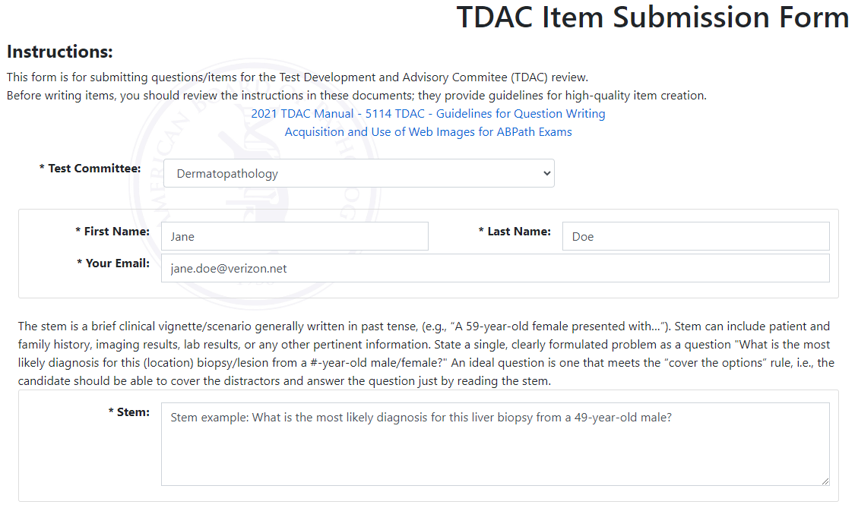
Stem (Required)
The stem of the question is entered in the first box. Icons are available for special emphasis (bold, italics, underline), superscript, subscript, insertion of table templates, find (search function), help, spell check, and special characters’ table.
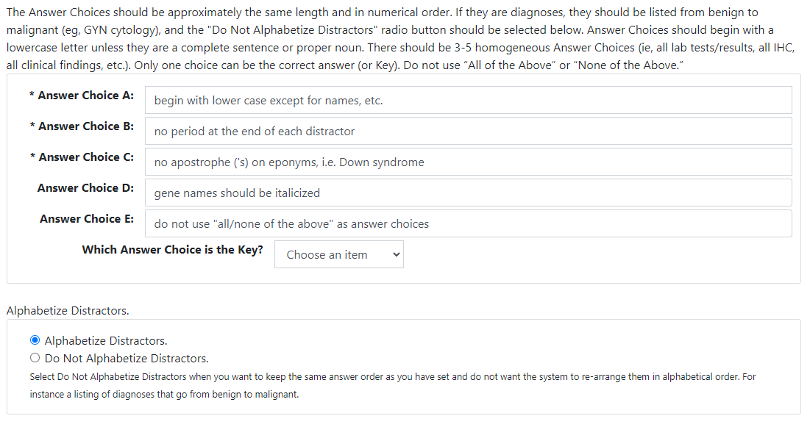
Distractors (Required)
- Distractors A through E are available.
- Each has icons for special emphasis, superscripts and subscripts, special characters’ table, and spell check.
- Indicate the correct answer by selecting it in the dropdown.
- Three (3) to five (5) answer choice are acceptable.
Alphabetize Distractors
When questions are edited, finalized, and moved to the permanent item bank by the ABPath staff, the answer will automatically be alphabetized. If you do NOT want the answers in alphabetical order (e.g., a listing of diagnoses that range from benign to malignant), select the radio button for "Do Not Alphabetize Distractors”.
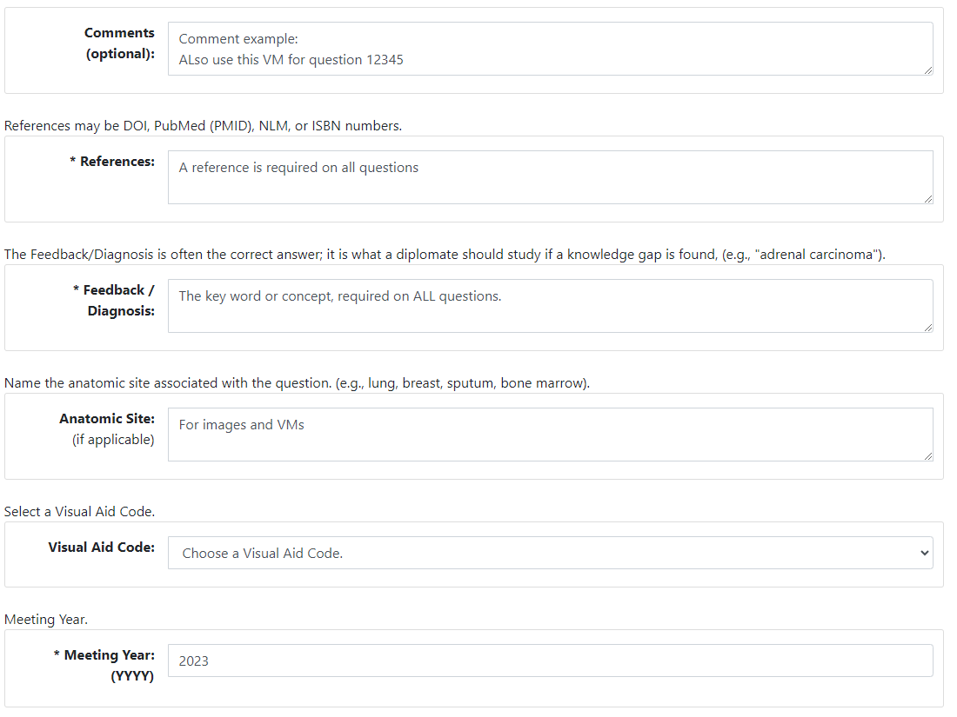
Comments
Any explanatory comments concerning the question should be entered here. (Comments are not required.)
References (Required)
- One (1) reference must be included for every question.
- Acceptable references include:
    - ISBN numbers of textbooks (page numbers are not required)
    - PubMed ID, DOI, or NLM numbers for articles
    - http links for reliable websites
Feedback Diagnosis (Required)
- Include on all questions to allow for easier question retrieval and detection of duplicate questions on exams.
- It should be the key words or concept the candidate would need to review to answer the question correctly.
- Examples of feedback diagnoses:
    - Diagnosis
    - Category
    - Concept
  - It is not necessarily the answer (for instance, if you have a list of age ranges), but rather what knowledge the question is testing.
Anatomic Site
Include for image and VM questions.
Visual Aid Code (Required)
Select from these visual aid code options:
- Cell Panel: used for Blood Banking
- EM/Figure: any electron micrograph or line-type image or graph
- Image: any photographic image, including images of microscopic fields
- Table: any table that is not part of the question stem
- Virtual (Glass): 1-2 glass slides will be sent to the ABPath office for scanning.
- Virtual (SVS): A thumb drive with .svs files will be sent to the ABPath office.
- Virtual (Glass) + Image: 1-2 glass slides will be sent to the ABPath office, as well as image(s) uploaded to the item.
- Virtual (SVS) + Image: A thumb drive with .svs files will be sent to the ABPath office, as well as image(s) uploaded to the item.
- None: No glass slide or thumb drive will be sent to the ABPath office, nor will any accompanying images be uploaded.
Please be precise in your selection, as this information is used by the ABPath staff for tracking purposes.
Meeting Date (Required)
Indicate the year of the TDAC meeting for which the question is being submitted for.
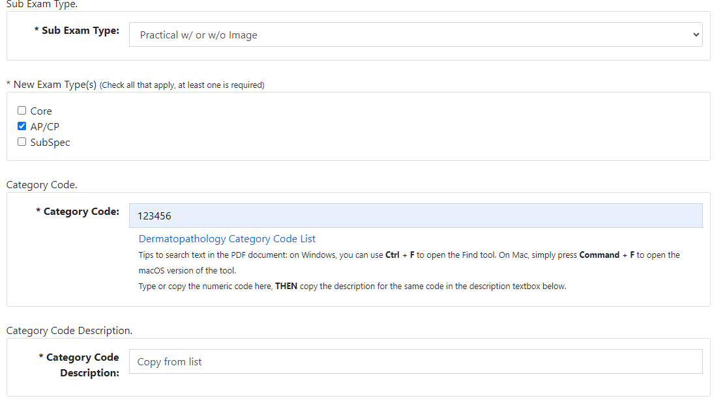
Sub Exam Type (Required)
Select from these options:
- Practical with/without image
- Virtual Microscopy
- Written/Recall
New Exam Type (Required)
Select the examination cohort for which this question is suitable. These choices are available:
- Core
- AP/CP
- SubSpec
Category Code (Number Required)
Enter the singular, most granular category code. (For more information, see the “Category Code” section in this policy.)
Category Code Description (Required)
Copy and paste the description listed with your selected Category Code number.
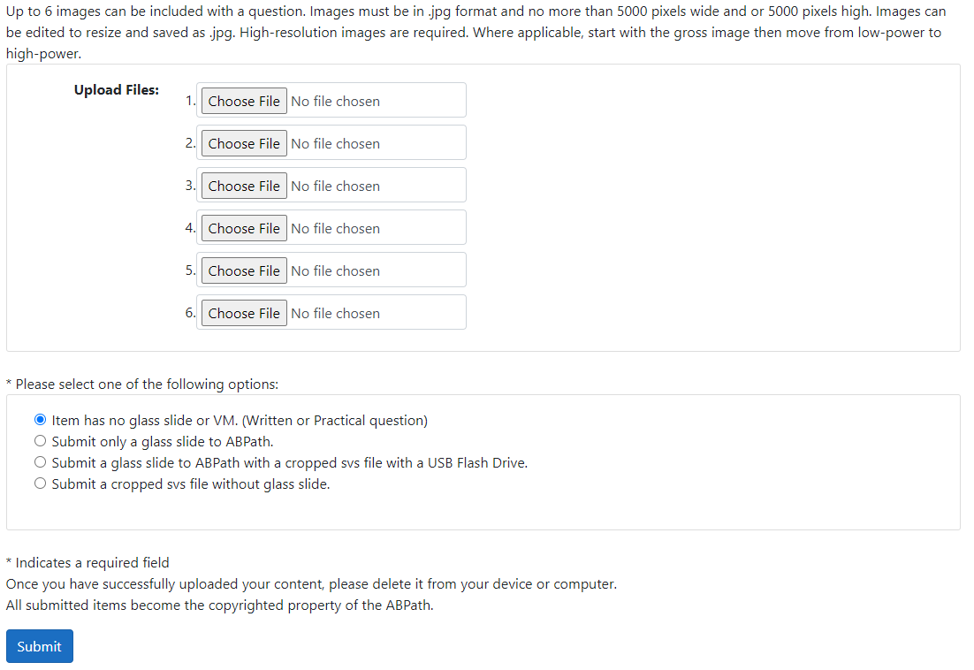
Upload Files
Upload up to six (6) images in spaces provided. Important Note: If you happen to get an error message of any kind upon submission, please note that your images will need to be reuploaded to the question. The only time images are fully uploaded and attached to a new item submission is when, once you have clicked “Submit”, you are brought back to the page which displays all items you have submitted for the given year.
Types of VMs Submitted
Item has no glass slide or VM (Written or Practical question).
The item submitted does not have an associated Virtual Microscopy.
Submit only a glass slide to ABPath.
Item submitted will be sending a single (1), or two (2), glass slides (labeled with the item’s associated accession number) to the ABPath.
Submit a glass slide to the ABPath with a cropped .svs file with a USB Flash Drive.
Item submitted will be sending a single (1), or two (2), glass slides (labeled with the item’s associated accession number), as well as a USB flash drive with a cropped .svs file of the scanned slide, named/saved with the item’s associated accession number.
Submit a cropped .svs file without glass slide.
The item submitter plans to submit a USB drive to the ABPath containing cropped .svs files named/saved with each item’s associated accession number.

If your institution is unwilling/unable to release glass slides or .svs files on a USB flash drive to the ABPath, please contact the TDAC Coordinator to coordinate next steps.

Submit (Required)
This button must be clicked in order to save the question and image(s). If required fields are missing information, a red alert will pop up at the bottom of the screen indicating what information is missing and must be entered. Important Note: If you happen to get an error message of any kind upon submission, please note that your images will need to be reuploaded to the question. The only time images are fully uploaded and attached to a new item submission is when, once you have clicked “Submit”, you are brought back to the page which displays all items you have submitted for the given year.
Edit/Delete
If you wish to edit/delete a question you have submitted, click on “Question Submission” in the toolbar and select your TDAC. Your questions will populate, and you will be able to edit or delete as necessary.

5118 – Examination Coding System
Effective Date: 07/01/1982
Revision Date: 06/26/2015
A coding system has been established by the ABPath for questions used on examinations. A searchable PDF file is available on the TDAC landing site (https://abpath.org/tdac-landing/), that contains the coding system outline, examination coding system, and a detailed listing of categories for use in creating questions for all primary, subspecialty, and Continuing Certification examinations.

5120 – Processing of Microscopic Slides & Images
Effective Date: 01/01/1992
Revision Date: 06/15/2021
RECEIPT OF MATERIALS
- Slides/SVS files are given to the TDAC Coordinator.
- TDAC Coordinator makes record of their arrival, and stores on TDAC shelf.
- Slides from TDAC members are accumulated until all or nearly all are received or until the assignment deadline is reached.
PROCESSING OF MICROSCOPIC SLIDES/.SVS FILES PRIOR TO TDAC MEETING
Glass Slide Submission
TDAC Coordinator
- Labels slides with AN# if not already done so by TDAC member
- Add each slide’s information to shared Excel document for VM tracking
- Give box of slides to Slide Librarian
Slide Librarian
- Scan slides and create batch
- Inform IT when batch is ready
IT
- Runs process
- Creates a master flash drive with all VMs for review at TDAC meeting
Thumb Drive Submission
TDAC Coordinator
- Gives thumb drive to IT as they arrive
IT
- Check drive for viruses
- Matches AN to Electronic Notebook
- Tile & load VM images
- Store thumb drive
- Link scans to electronic questions
- Creates a master flash drive with all VMs for review at TDAC meeting
PROCESSING OF VM MATERIALS AFTER TDAC MEETING
TDAC COORDINATOR
- Sends homework reminders for VM
- Creates clones & marks shares VA
- Creates 4 Chron. Lists
- File
- Item Bank Specialist
- IT
- Slide Librarian
- Alerts IT and Slide Librarian of deleted VMs
SLIDE LIBRARIAN
- Adds clone ANs to glass slides
- Adds clone Ans to master Excel
- Removes deleted ANs in master Excel
- Destroys deleted glass slides
IT
- Crops scans as indicated at TDAC
- Removes scans of deleted questions
PROCESSING OF IMAGES
- Digital images should be submitted on-line through the TDAC Electronic Notebook template with questions prior to the TDAC meeting.
- After the TDAC, deleted and reworked questions with images are removed from the questions.
- Questions are delivered to the Editor for editing.

5122 – Continuing Certification (formerly MOC) – Introduction
Effective Date: 05/07/2012
Revision Date: 06/15/2021
- Continuing Certification (CC) is a program designed to ensure that physicians certified by a member board of the American Board of Medical Specialties (ABMS) are committed to maintaining the knowledge and skills that are demonstrated upon their initial certification and are committed to lifelong learning and competency by keeping up with the advances in their area of specialty.
- CC programs are required to comply with ABMS Standards for MOC/CC. There are 4 parts:
  - Part I: Professionalism and Professional Standing
  - Part II: Lifelong Learning and Self-Assessment
  - Part III: Assessment of Knowledge, Judgement, and Skills
  - Part IV: Improvement in Medical Practice
- All diplomates of the ABPath certified in 2006 or later are required to participate in CC to maintain certification. Diplomates must maintain primary certification to maintain subspeciality certification.
- All new TDAC members are required to participate in CC. For non-time limited diplomates, this does not jeopardize their lifetime certifications.
- Details regarding Continuing Certification (CC) are available on the ABPath website at www.abpath.org.

5124 – Standard Setting
Effective Date: 02/01/2023
Revision Date:
Introduction to Standard Setting
Standard setting is the process of determining a criterion-reference standards, or cut score, for an examination or a section of an examination. Multiple standard setting methods have been developed by educational measurement researchers. The American Board of Pathology uses a modified-Angoff method for standard setting and the Hofstee method as an alternative method. The goal of the standard setting process is to determine a cut score that vest reflects a minimum passing score for the exam in question.
Standard Setting Meeting
When an exam undergoes a standard setting every three (3) to five (5) years, the ABPath TDAC Coordinator will contact a group of subject matter experts (SMEs) to convene online through a virtual meeting software (e.g. Zoom). Research recommends ten (10) to fifteen (15) panelists per meeting¹. Prior to the meeting, the psychometrician will prepare an Excel spreadsheet with rows for each item, columns for panelists to place their ratings and notes, and a tab for Hostee ratings.
Modified-Angoff Training and Scoring
The facilitator will inform SMEs about the “minimally competent candidate”, in which a candidate has the bare minimum ability needed to be certified. The panelists will be instructed to consider one-hundred (100) such candidates. For each item, the panelists will read the item, then estimate how many of these 100 minimally-competent candidates would, not should, answer the item correctly, rounded to the nearest number divisible by 5 (e.g. 60, 65, 70, etc.). After all panelists provide an initial estimate, the facilitator will review the item statistics (p-value difficulty and point-biserial discrimination) for each item, at which point the panelists may amend their scores.
Round-Robin Discussion
For the first few items, it is recommended that the facilitator conduct round-robin discussions to ensure that the panelists understand the rating process. The facilitator may also conduct a round-robin discussion on an item after a non-specific interval to gauge the panelists’ consistency over time.
Breaks
The facilitator will offer breaks approximately every two (2) hours. It is recommended that breaks are taken immediately after completing a section of items, should the exam comprise multiple sections.
Hofstee Training and Scoring
Following the completion of the modified-Angoff ratings, the facilitator will introduce the Hofstee method to the panelists. The facilitator will explain how the method will use four ratings from each panelist: A1, the minimum acceptable percent-correct cut score based on the items seen during the modified-Angoff ratings; A2, the maximum acceptable percent-correct cut score; B1, the minimum acceptable percent of candidates to fail the exam; and B2, the maximum acceptable percent of candidates to fail the exam. Following the training, the panelists will provide their ratings for each of the four parameters, rounded to the nearest percent divisible by 5.
Submission of Ratings
Following the completion of the Hofstee ratings, each panelist will submit their ratings form to the psychometrician via email.
Standard Setting Psychometrics
The role of the psychometrician at ABPath is to perform the necessary calibrations and analyses of the exam data and panelist responses, then present the results to the Committee on Exams.
Pre-Calibration
When possible, the psychometrician will combine three (3) years’ worth of examinee data into a benchmarking data set. This process provides item difficulty estimates based on a larger span of time than would a single year’s responses. The psychometrician will perform a Rasch model analysis on the benchmarking data set to derive logit-form difficulty values (BDIFFs) for all items in the benchmarking set using WINSTEPS, a computer program that uses logistic modeling based on item response theory to estimate item difficulties and person abilities. The psychometrician will then perform a WINSTEPS analysis on the standard setting exam form along, using the benchmarking BDIFFs for each item on the form.
In preparation for the Hofstee method, the psychometrician will construct an ogive (i.e., cumulative frequency polygon) of the candidate’s percent-correct scores from the exam used for standard setting.
Panelist Rating Analysis
The psychometrician will calculate the mean and standard deviation for each item and for each panelist. The mean of the item means is then calculated. This value will be the primary recommended cute score (i.e. criterion-referenced standard) for the upcoming exam. The standard deviations for both item ratings and panelist ratings will also be calculated. These standard deviations are then added to create the standard error of estimate for the cut score. This standard error will be subtracted from and added to the criterion-referenced standard to create a 68% confidence interval for a “true” recommended cut score if an infinite number of panelists participated in the standard setting.
The psychometrician will analyze panelists ratings for each individual item to check for outliers (i.e., ratings that are two standard deviations above or below the average rating). At the psychometrician’s discretion, outlier ratings may be removed on an item-by-item basis to ensure that the overall average rating and standard deviation of each item are not affected by these outliers.
Logit Form
The criterion-referenced standard and its adjusted versions will then be converted to a logit score as determined by the Rasch calibration of the reference exam. After calibrating the exam using WINSTEPS, the psychometrician will convert the percent-correct cut score from the standard setting into a number-correct cut score based on the number of items on the exam form used in the standard setting. The psychometrician will then use the Person Score Table from the WINSTEPS calibration to determine the logit score that corresponds to the number-correct cut score. Similar logit score conversions will then be found for the 68% confidence interval. Finally, the psychometrician will use the value of the SEM to calculate four more logit values: two SEM above, one SEM above, one SEM below, and two SEM below the recommended cut score.
Hofstee Rating
Following the Angoff analysis, the psychometrician will calculate the average values of A1, A2, B1, and B2 from the panelists’ Hofstee ratings. The psychometrician will then formulate a line segment with endpoints (A1, B2) and (A2, B1) using the average values of each respective rating. The psychometrician will use this line segment and the ogive created earlier to determine the point at which these lines intersect. If the point of intersection occurs between the average values of A1 and A2, then the value of A corresponding to the intersection point is the Hofstee-recommended percent-correct cut score. Otherwise, the Hofstee-recommended cut score must be adjusted by at least one SEM such that the cut score occurs between the values of A1 and A2.
Cut Score Recommendation
The psychometrician will calculate the average percent-correct cute score and the standard deviation of these cut scores from recent administrations of the exam. At least five years’ worth of cut scores should be used. The psychometrician will also calculate one/two standard deviations above/below the average percent-correct cut-score. The psychometrician will create a graph showing the percent-correct cut-scores with lines for the five values calculated earlier.
If the Angoff-recommended cut score is within one standard deviation of the average percent-correct cut score, then the psychometrician will recommend that this cut score’s logit-form equivalent be used for future exam adminstrations. The Hofstee-recommended cut score is more than one standard deviation above or below the average cut score. If both recommended cut scores are at least two standard deviations above or below the average cut score, then adjustments to the cut score will also be recommended.
Summary Report
The psychometrician will prepare a summary report of the standard setting session and its results. The report will describe the standard setting process and the standard setting session, present results from the standard setting session and analyses, and provide a recommended cut score for administrations of the exam.
The summary report will contain key data used to support the recommended cut score. These data include a Wright map from the WINSTEPS output that shows the benchmarked logit-scale difficulty rating for each item and the logit-scale ability score estimate for each candidate based on the benchmarked items. The Wright map will also include lines depicting the location of the recommended cut scores for both the modified-Angoff and Hofstee methods with lines above and below depicting adjustments based on standard deviation and SEM. The summary report also includes projected fail rates at each recommended cut score, including adjusted cut scores, and a history of fail rates for the exam.
The draft of the summary report will be presented to the CEO and COO of the American Board of Pathology for review. The psychometrician will then edit the summary report based on comments and suggestions made by the CEO and COO, then present a finalized version of the report to deliver to the Committee on Exams.

5200 – Continuing Medication Education
Effective Date:
Revision Date: 06/15/2021
TDAC members can claim 10 AMA PRA Category 1 CME credits for test writing activities.
The ABPath gratefully acknowledges the U.S. and Canadian Academy of Pathology (USCAP) for sponsoring this CME activity. Prior to the committee meeting, USCAP will ask you to complete a COI disclosure form. After the meeting, USCAP will send you a link to complete an online meeting evaluation. Once submitted, USCAP will issue your CME certificate.

5201 – Resources for Good Question Writing
Effective Date:
Revision Date: 01/01/2019
The National Board of Medical Examiners (NBME) has an excellent resource for question writing entitled “Constructing Written Test Questions For the Basic and Clinical Sciences”. This can be viewed and downloaded from: www.nbme.org.
Search on the booklet title. Section II “Writing One-Best-Answer Questions” is the most relevant section, as the booklet is quite lengthy. Their only request is that you maintain their statement of copyright.
There is an excellent brief video tutorial that all TDAC members must view prior to item writing at: www.nbme.org/IWTutorial.

